**Configuring PVDesktop to Build**

On build, the PVDesktop solution starts an external program, the DemoMap.exe, which is a basic wrapper for the DotSpatial functions. At some point it will be customized for our uses. Below is the procedure for setting up the project to build.

1. Open the PVDesktop.sln solution (Located in pvdesktop/PVDesktop/ in the Source Control Explorer, under tfs.codeplex.com\TFS03)
2. Open the Solutions Explorer
3. Right click on the PVDesktop title at the top and click properties.
4. Click on the Debug tab on the side
5. Under “Start Action” click “Start External Program.” Direct it to the DemoMap.exe located in pvdesktop/PVDesktop/

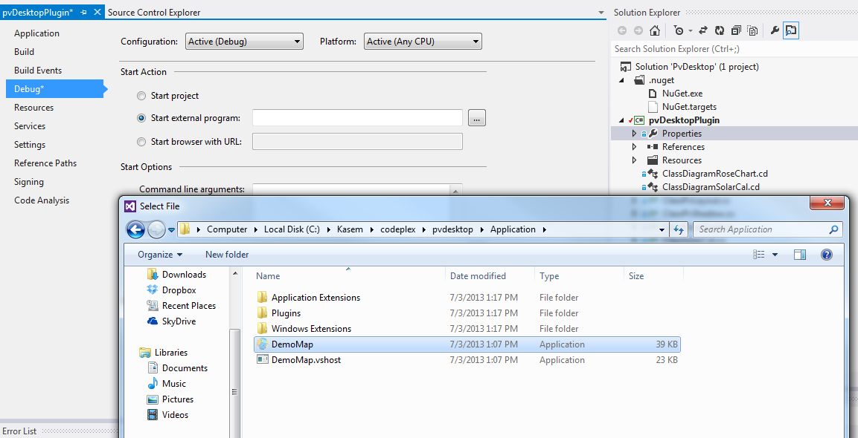

Output path in build tab of properties: “PVDesktop\Application\Plugins\pvmapper\”

Load DotSpatial Files in Application folder as references

Load other dlls in Application/plugins/pvmapper

